

**Assignment No: 01**

Submitted by:

Name : Haseeb Ullah

ID: F20232661009

Section: V21

Submitted to:

Name: Sir Raiz Ahmed

PF LAB : 19 Questions

**Address:** C-II Block C 2 Phase 1 Johar Town, Lahore, Punjab 54770.

University of Management & Technology.

1. Write a C++ program to display your name and a welcome message using the "cout" statement.

Ans:

|  |
| --- |
| #include <iostream>  using namespace std;  int main(){      cout << "Wellcome to code with raiz" << endl;      cout << "My name is Haseeb";      return 0;  } |

Output

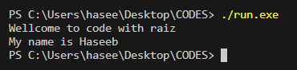

1. Create a program that takes two integer inputs from the user and displays their sum using "cout."

Ans:

|  |
| --- |
| #include <iostream>  using namespace std;  int main(){      int a,b,sum;      cout << "if you want sum of two number\n";      cout << "Enter the first value: ";      cin >> a;      cout << "Enter the first value: ";      cin >> b;      sum = a + b;      cout << "the sum of two number is: " << sum;      return 0;  } |

Output

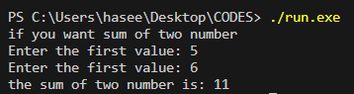

1. Write a C++ program that calculates the area of a rectangle. Prompt the user for the length and width, and then display the result using "cout."

Ans:

|  |
| --- |
| #include <iostream>  using namespace std;  int main(){      double lenght,width,area;      cout << "calculation for the area of rectangle\n";      cout << "Enter the lenght of the area: ";      cin >> lenght ;      cout << "Enter the width of the area: " ;      cin >> width;      area = lenght * width;      cout << "the area of the Rectangle is :" << area ;      return 0;  } |

Output

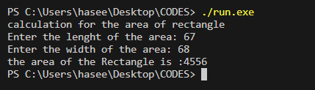

1. Develop a program that converts a temperature in Celsius to Fahrenheit. Prompt the user for the temperature in Celsius, perform the conversion, and display the result using "cout."

Ans:

|  |
| --- |
| #include <iostream>  using namespace std;  //Write a program converts a temperature from Celsius to Fahrenheit.  //Use the following formula: F = 1.8 x C + 32.  int main() {    double celsius;  double fahrenheit;    cout << "Enter the Celsius: ";  cin >> celsius;    fahrenheit = (1.8 * celsius) + 32;    cout << "Temperature in Fahrenheit is: " << fahrenheit;    return 0;  } |

Output

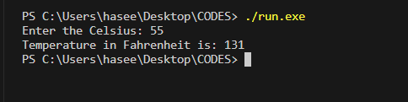

1. Create a simple calculator program that takes two numbers and an operator (+, -, *, /) as input and displays the result of the operation using "cout."

Ans:

|  |
| --- |
| #include <iostream>  using namespace std;  int main() {  double num1, num2, result;  char operation;  cout << "Enter the 1st number, operation and 2nd number: ";  cin >> num1 >> operation >> num2;  switch (operation) {  case '+':  result = num1 + num2;  break;  case '-':  result = num1 - num2;  break;  case '*':  result = num1 * num2;  break;  case '/':  if (num2 != 0) {  result = num1 / num2;  } else {  cout << "Enter the valid operation. ";  return 1;  }  break;  default:  cout << "Invalid operator." ;  return 1;  }    cout << "Result: " << result ;    return 0;  } |

Output

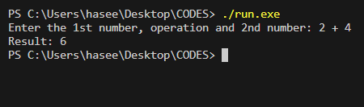

1. Write a program to find the square of a given number. Prompt the user for the input and display the square using "cout."

Ans:

|  |
| --- |
| #include <iostream>  #include <cmath>  using namespace std;  int main()  {     float radius, area;     cout << "Enter Radius of the circle: ";     cin >> radius ;     area = 3.14 * pow(radius, 2);     cout <<"Area of the circle is:"<< area <<endl;      return 0;  } |

Output

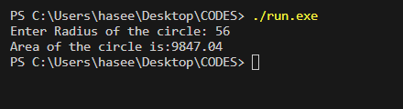

1. Implement a program that calculates the factorial of a positive integer entered by the user and displays the result using "cout."

Ans:

|  |
| --- |
| #include <iostream>  using namespace std;  int main()  {    int num;     int factorial = 1;     cout << "the factorail program\n";     cout << "Enter the number: ";     cin >> num;     if(num > 0){     for(int i = 1; i <= num; ++i)     factorial *= num;     cout << "Factorail of " << num << " is " << factorial;     return 1;     }else{      cout << "Enter the non nagetive number";      return 1;     }      return 0;  } |

Output

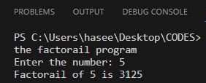

1. Create a program that takes a character as input and displays its ASCII value using "cout."

Ans:

|  |
| --- |
| #include <iostream>  using namespace std;  int main(){      char character;      cout << "Enter the single character: ";      cin >> character;      int value = character;      cout << "For the character "<< character << "value is: "<<value;      return 0;  } |

**Output**

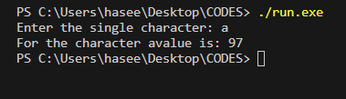

1. Write a program that prompts the user for their name and then displays a personalized greeting using "cout."

Ans:

|  |
| --- |
| #include <iostream>  #include <string>  using namespace std;  int main() {      string name;      cout << "Enter your name: ";      getline(cin, name);        cout << " Welcome to my program: " << name;      return 0;  } |

Output

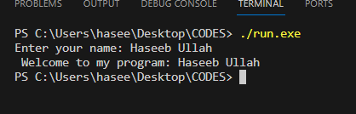

1. Develop a program that simulates a simple shopping cart. Allow the user to enter the names and prices of items, and then display the total price using "cout."

Ans:

|  |
| --- |
| #include <iostream>  using namespace std;  int main (){        double item1, item2, item3, item4, totalcost;      item1= 80000;      item2=3334;      item3=243;      item4=300;      cout << "Name: Laptop. \n";      cout << "Price: " << item1 << "\n";      cout << "Name: Screen. \n";      cout << "Price: " << item2 << "\n";      cout << "Name: Mouse. \n";      cout << "Price: " << item3 << "\n";      cout << "Name: Keyboard. \n";      cout << "Price: " << item4 << "\n";      totalcost = item1 + item2 + item3 + item4;      cout << "Total cost is: " << totalcost;      return 0;  } |

Output

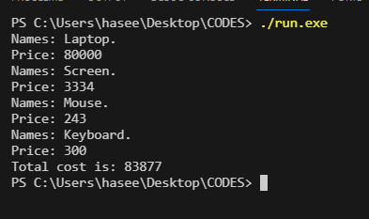

1. Create a program that displays the first 10 natural numbers using "cout."

Ans:

|  |
| --- |
| #include <iostream>  using namespace std;  // Create a program that displays the first 10 natural numbers using "cout."  int main() {      int nums;        cout << "the first 10 natural number is: ";      for ( nums = 1; nums <= 10; ++nums){      cout << nums << ", ";      }      return 0;  } |

Output

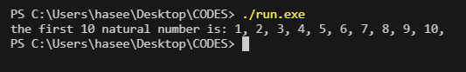

2nd Way

|  |
| --- |
| #include <iostream>  using namespace std;  int main(){      cout << "the first 10 natural number: ";      cout << "1, 2, 3, 4, 5, 6, 7, 8, 9, 10.";      return 0;  } |

Output

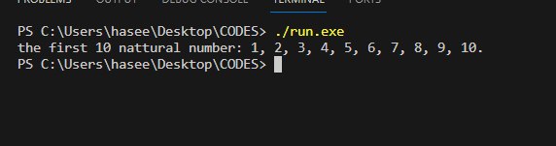

1. Write a C++ program that displays the multiplication table of a number entered by the user using "cout."

Ans:

|  |
| --- |
| #include <iostream>  using namespace std;  int main() {      int num;      cout << "Enter the number: ";      cin >> num;      cout << "\"Multiplication table of " << num << "\"\n";      for(int i = 1; i <= 10; ++i ){          cout << num << " * " << i << " = " << num * i << "\n";      }      return 0;  } |

Output

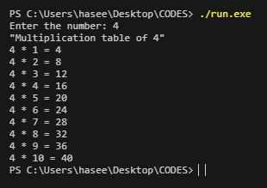

2nd Way

|  |
| --- |
| #include <iostream>  using namespace std;  int main() {      int num;      cout << "Enter the number: ";      cin >> num;      cout << "\"Multiplication table of " << num << "\"\n";      cout << num << " * " << 1 << " = " << (num * 1)<< endl;      cout << num << " * " << 2 << " = " << (num * 2)<< endl;      cout << num << " * " << 3 << " = " << (num * 3)<< endl;      cout << num << " * " << 4 << " = " << (num * 4)<< endl;      cout << num << " * " << 5 << " = " << (num * 5)<< endl;      cout << num << " * " << 6 << " = " << (num * 6)<< endl;      cout << num << " * " << 7 << " = " << (num * 7)<< endl;      cout << num << " * " << 8 << " = " << (num * 8)<< endl;      cout << num << " * " << 9 << " = " << (num * 9)<< endl;      cout << num << " * " << 10 << " = " << (num * 10)<< endl;      return 0;  } |

Output

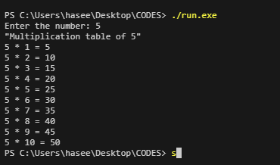

1. Develop a program that converts a distance in kilometers to miles and displays the result using "cout."

|  |
| --- |
| #include <iostream>  using namespace std;  int main (){      double mile = 0.62137119;      double kilometers,result;      cout << "This program converts a distance in kilometers to miles\n";      cout << "Enter kilometers: ";      cin >> kilometers;      result = kilometers * mile;      cout << "the total miles is: " << result ;      return 0;  } |

Output

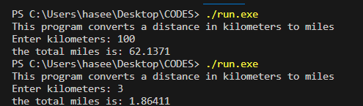

1. Create a simple menu-driven program that displays options to the user and prints their choice using "cout."

Ans

|  |
| --- |
| #include <iostream>  using namespace std;  int main (){      char choice;        cout << "Menu is following.\n";      cout << "1. Pizza .\n";      cout << "2. Burger.\n";      cout << "3. Chicken-zinger.\n";      cout << "4. desserts.\n";      cout << "Enter Choice (1-4): ";      cin >> choice;      switch (choice)      {      case '1':          cout << "you order Pizza, its on the way.";          break;      case '2':          cout << "you order Burger, its on the way.";          break;      case '3':          cout << "you order Chicken-Zinger, its on the way.";          break;      case '4':          cout << "you order desserts, its on the way.";          break;      default:          cout << "Enter the valid choice from 1 to 4";          break;      }      return 0;  } |

OUTPUT

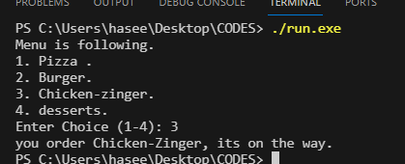

1. Write a program to display a countdown from 10 to 1, each number on a separate line using "cout."

Ans:

|  |
| --- |
| #include <iostream>  using namespace std;  int main (){      cout << "10\n";      cout << "9\n";      cout << "8\n";      cout << "7\n";      cout << "6\n";      cout << "6\n";      cout << "5\n";      cout << "4\n";      cout << "3\n";      cout << "2\n";      cout << "1\n";      return 0;  } |

Output

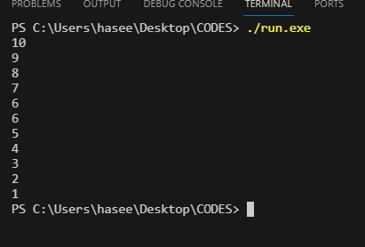

2nd way

|  |
| --- |
| #include <iostream>  #include <cmath>  using namespace std;  int main (){      for (int i = 10; i >= 1; --i)      cout << i << "\n";      return 0;  } |

Output

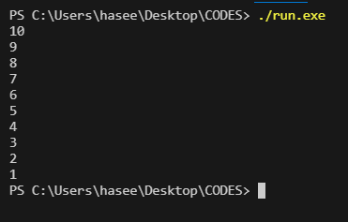

1. Implement a program that displays the square roots of the first 10 positive integers using "cout."

Ans:

|  |
| --- |
| #include <iostream>  #include <cmath>  using namespace std;  int main (){      int positive_int;      for( positive_int = 1; positive_int <= 10; ++positive_int){          cout << "For number " << positive_int << ", Square root is: " << sqrt(positive_int)  << endl ;      }      return 0;  } |

Output

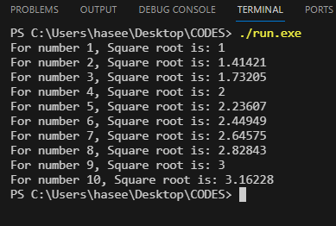

2nd Way

|  |
| --- |
| #include <iostream>  #include <cmath>  using namespace std;  int main (){      cout << "For number " << 1 << ", Square root is: " << sqrt(1)  << endl ;      cout << "For number " << 2 << ", Square root is: " << sqrt(2)  << endl ;      cout << "For number " << 3 << ", Square root is: " << sqrt(3)  << endl ;      cout << "For number " << 4 << ", Square root is: " << sqrt(4)  << endl ;      cout << "For number " << 5 << ", Square root is: " << sqrt(5)  << endl ;      cout << "For number " << 6 << ", Square root is: " << sqrt(6)  << endl ;      cout << "For number " << 7 << ", Square root is: " << sqrt(7)  << endl ;      cout << "For number " << 8 << ", Square root is: " << sqrt(8)  << endl ;      cout << "For number " << 9 << ", Square root is: " << sqrt(9)  << endl ;      cout << "For number " << 10 << ", Square root is: " << sqrt(10)  << endl ;      return 0;  } |

**Output**

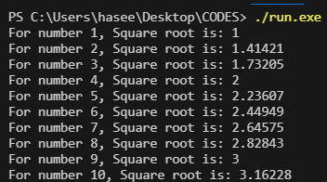

1. Create a program that calculates and displays the perimeter of a rectangle. Prompt the user for the length and width using "cout."

Ans:

|  |
| --- |
| #include <iostream>  using namespace std;  int main (){       double lenght, width, perimeter;     cout << "Enter lenght: ";     cin >> lenght;     cout << "Enter width: ";     cin >> width;     perimeter = 2 * (lenght + width);     cout << "The perimeter of area is: " << perimeter ;      return 0;  } |

**Output**

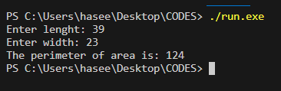

1. Write a program to display a pattern of even numbers from 2 to 20 using "cout."

Ans:

|  |
| --- |
| #include <iostream>  using namespace std;  int main (){      cout << "Even number: 2, 4, 6, 8, 10, 12, 14, 16, 18,20.";      return 0;  } |

Output

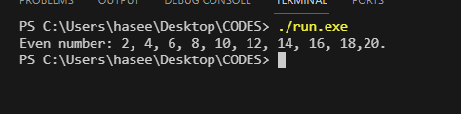

1. Develop a program that displays the current date and time using "cout."

|  |
| --- |
| #include <iostream>  using namespace std;  int main (){      cout << "The current Date and Time: (12/02/2023) -> 10:12pm.";      return 0;  } |

**Output**

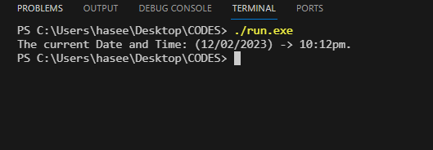

**2ND Way**

|  |
| --- |
| #include <iostream>  #include <ctime>  #include <string>  using namespace std;  int main() {      time_t present_time = time(0);      string timepatturnline = ctime(&present_time);      cout << "Current Date and Time: " << timepatturnline << endl;        return 0;  } |

Output

